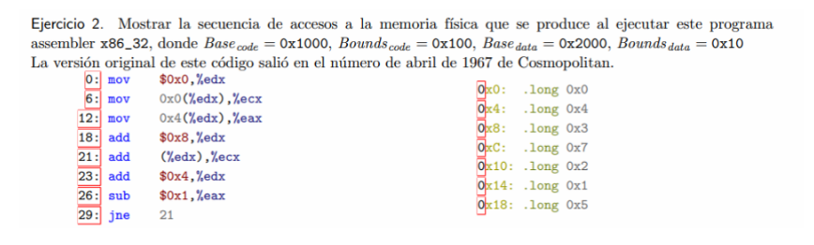

| Linea | Memoria accedida | Anotaciones |
| --- | --- | --- |
| 0  6  12  18  21  23  26  29  21  23  26 | 0x0  0x4  -  0x8  -  -  -  0x10  -  - | edx = 0x0  ecx = 0x0 + (0x0)  eax = 0x4 + (0x0) == 0x4  edx = 0x8  ecx = 0x3  edx = 0xC  eax = 0x3  volvemos a 21  ecx = 0x10  edx = 0x10  eax = 0x2 |

mov (dir de memoria), variable

esto me parece que lo resolvimos mal. puto

codigo [0x1000,0x1100] si me salgo de esto SEGMENTATION FAULT

data [0x2000, 0x2010]

Cada vez que se accede a una linea se hace el calculo:

Base(code)+linea

⡴⠒⣄⠀⠀⠀⠀⠀⠀⠀⠀⠀⠀⠀⠀⠀⠀⠀⠀⠀⠀⠀⠀⠀⠀⠀⠀⠀⠀⠀⠀⠀⠀⠀⠀⣼⠉⠳⡆⠀

⣇⠰⠉⢙⡄⠀⠀⣴⠖⢦⠀⠀⠀⠀⠀⠀⠀⠀⠀⠀⠀⠀⠀⠀⠀⠀⠀⠀⠀⠀⠀⠀⠀⠀⠀⠘⣆⠁⠙⡆

⠘⡇⢠⠞⠉⠙⣾⠃⢀⡼⠀⠀⠀⠀⠀⠀⠀⢀⣼⡀⠄⢷⣄⣀⠀⠀⠀⠀⠀⠀⠀⠰⠒⠲⡄⠀⣏⣆⣀⡍

⠀⢠⡏⠀⡤⠒⠃⠀⡜⠀⠀⠀⠀⠀⢀⣴⠾⠛⡁⠀⠀⢀⣈⡉⠙⠳⣤⡀⠀⠀⠀⠘⣆⠀⣇⡼⢋⠀⠀⢱

⠀⠘⣇⠀⠀⠀⠀⠀⡇⠀⠀⠀⠀⡴⢋⡣⠊⡩⠋⠀⠀⠀⠣⡉⠲⣄⠀⠙⢆⠀⠀⠀⣸⠀⢉⠀⢀⠿⠀⢸

⠀⠀⠸⡄⠀⠈⢳⣄⡇⠀⠀⢀⡞⠀⠈⠀⢀⣴⣾⣿⣿⣿⣿⣦⡀⠀⠀⠀⠈⢧⠀⠀⢳⣰⠁⠀⠀⠀⣠⠃

⠀⠀⠀⠘⢄⣀⣸⠃⠀⠀⠀⡸⠀⠀⠀⢠⣿⣿⣿⣿⣿⣿⣿⣿⣿⣆⠀⠀⠀⠈⣇⠀⠀⠙⢄⣀⠤⠚⠁⠀

⠀⠀⠀⠀⠀⠀⠀⠀⠀⠀⠀⡇⠀⠀⢠⣿⣿⣿⣿⣿⣿⣿⣿⣿⣿⣿⡄⠀⠀⠀⢹⠀⠀⠀⠀⠀⠀⠀⠀⠀

⠀⠀⠀⠀⠀⠀⠀⠀⠀⠀⠀⡀⠀⠀⣿⣿⣿⣿⣿⣿⣿⣿⣿⣿⣿⣿⣿⡀⠀⠀⢘⠀⠀⠀⠀⠀⠀⠀⠀⠀

⠀⠀⠀⠀⠀⠀⠀⠀⠀⠀⠀⡇⠀⢰⣿⣿⣿⡿⠛⠁⠀⠉⠛⢿⣿⣿⣿⣧⠀⠀⣼⠀⠀⠀⠀⠀⠀⠀⠀⠀

⠀⠀⠀⠀⠀⠀⠀⠀⠀⠀⠀⢠⡀⣸⣿⣿⠟⠀⠀⠀⠀⠀⠀⠀⢻⣿⣿⣿⡀⢀⠇⠀⠀⠀⠀⠀⠀⠀⠀⠀

⠀⠀⠀⠀⠀⠀⠀⠀⠀⠀⠀⠘⡇⠹⠿⠋⠀⠀⠀⠀⠀⠀⠀⠀⠀⠙⢿⡿⠁⡏⠀⠀⠀⠀⠀⠀⠀⠀⠀⠀

⠀⠀⠀⠀⠀⠀⠀⠀⠀⠀⠀⠀⠻⣤⣞⠁⠀⠀⠀⠀⠀⠀⠀⠀⠀⠀⢢⣀⣠⠇⠀⠀⠀⠀⠀⠀⠀⠀⠀⠀

⠀⠀⠀⠀⠀⠀⠀⠀⠀⠀⠀⠀⠀⠀⠀⠙⠲⢤⣀⣀⠀⢀⣀⣀⠤⠒⠉⠀⠀⠀⠀⠀⠀⠀⠀⠀⠀⠀⠀⠀

| linea | memoria accedida |
| --- | --- |
| 0: mov $0x0, %edx  6: 0x0(%edx), %ecx  12: mov 0x4(%edx),%eax  18 : add $0x8, %edx  21: add (%edx), %ecx  23: add $0x4, %edx (edx = 12)  26: sub $0x1, %eax (eax=3)  29: jne 21 | base_code + linea = 0x1000  base_data + dir = 0x2000  0x2000+0x4 = 0x2004  0x1018  base_data+0x8 = 0x2008  0x1023  0x1026  0x1029 |

para hacerlo me sirvio verlo como ecx = MEM[0x0] x ej en la linea 0xA6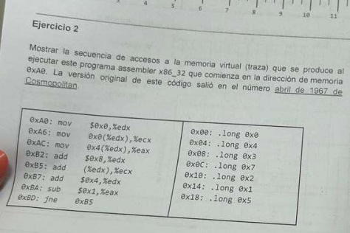

1

2 ♦

3

4

5

6

7

8

| linea | memoria accedida | anotaciones ;) |
| --- | --- | --- |
| 1  2  3  4  5  6  7  8 | na  0x00  0x04  -  0x08  -  -  - | edx = 0x0;  ecx = 0x0 por ♦  eax = 0x4  edx = 0x8  ecx =0x3  edx=0xC  eax = 0x3   * eax!=0 |
| 5  6  7  8 | 0x0C  -  -  - | ecx = 0x10  edx = 0x10  eax = 0x2  eax!=0 |
| 5  6  7  8 | 0x10  -  - | ecx = 0x12  edx = 0x14  eax = 0x1  eax !=0 |
| 5  6  7  8 | 0x14  -  -  - fin | ecx = 0x13  edx = 0x18  eax = 0  eax = 0 |

1100 = 0xC

0100 = 0x4 = 10000

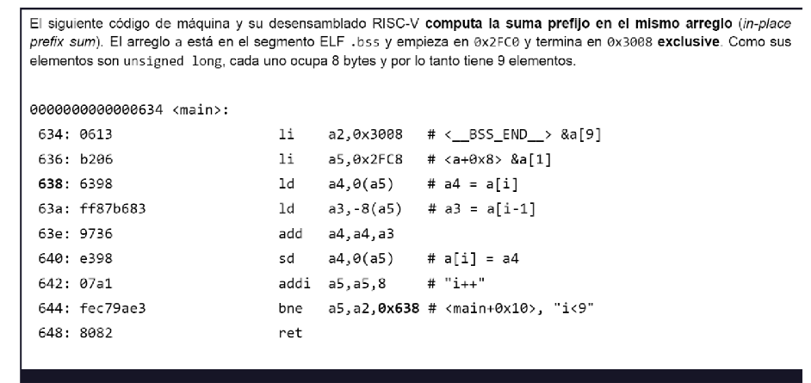

1

2

3

4

5

6

7

8

9

[0x2FC0, 0x3008] nasi CADA ELEM OCUPA 8 BYTES

flayaste

| linea | traza de memoria | anotaciones |
| --- | --- | --- |
| 1  2  3  4  5  6  7  8  9 |  | Creo que se le asigna el final del array a a2 |